**How** **to** **Set up** **and** **Reskin:**

1. **Download and unzip game project files.**
2. **Run Unity Hub.**
3. **Click to the “Add” button.**

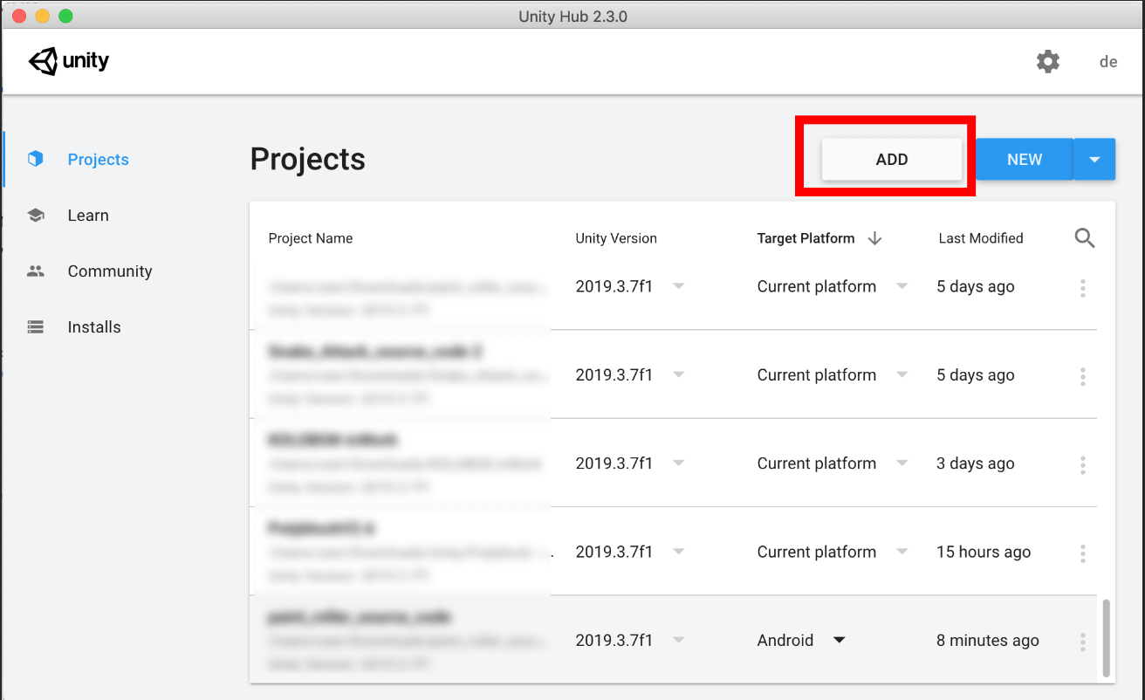

1. **Choose the project folder.**

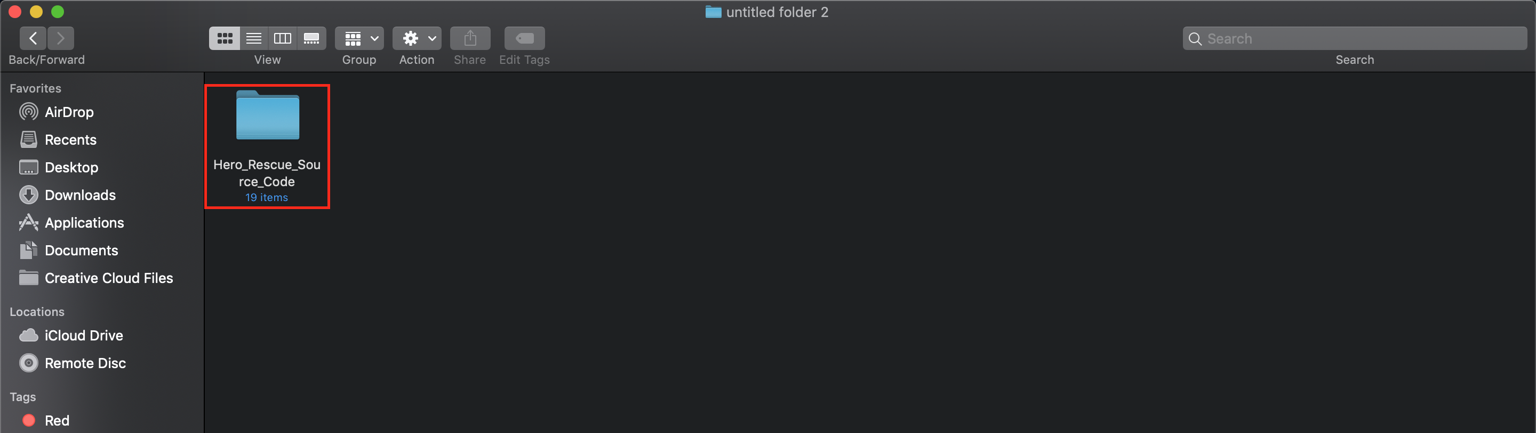

**5. Open the project in Unity**

After adding a project in “**Unity Hub”**, it will appear in the "**Project name**" list, next in the field "**Unity version**" you need to select the Unity version "**2019.3.7f1**" and in the field "Platform" select "**Android**”.

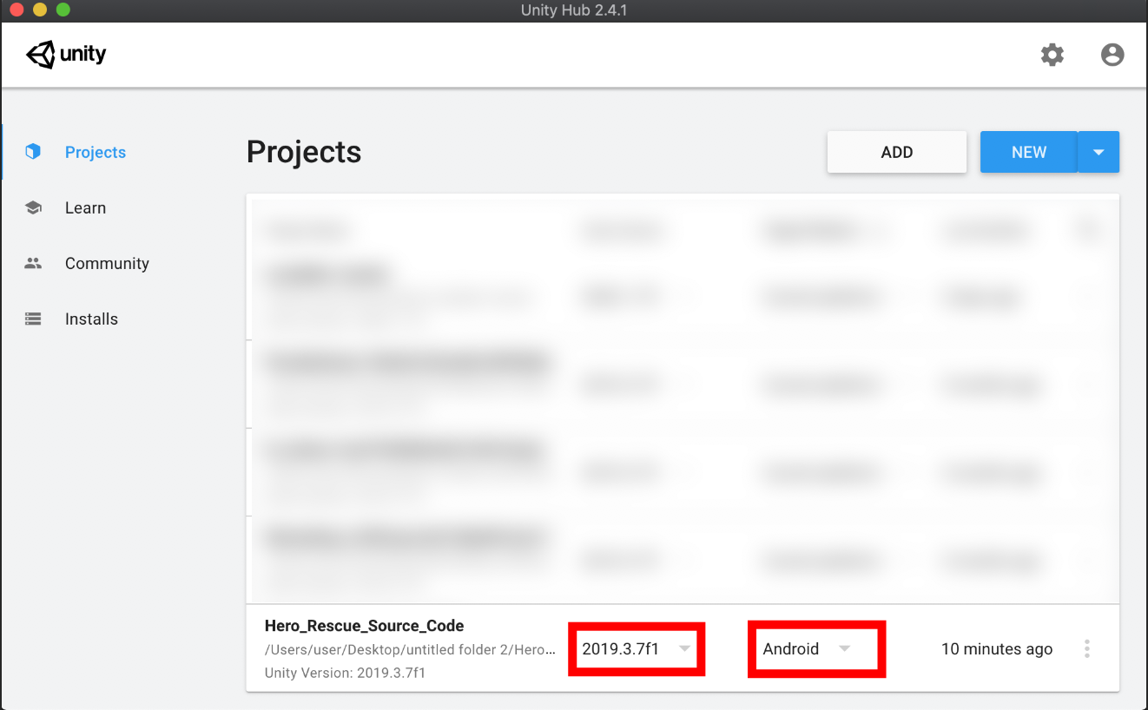

**6.Wait..project importing.**

**7.Open main scene.**

When importing files complete go to "**Assets**" - > "**Scenes**" and open “**MainMenu.unity**", also you can open “**MainGame**” or “**LevelEditor**” scene.

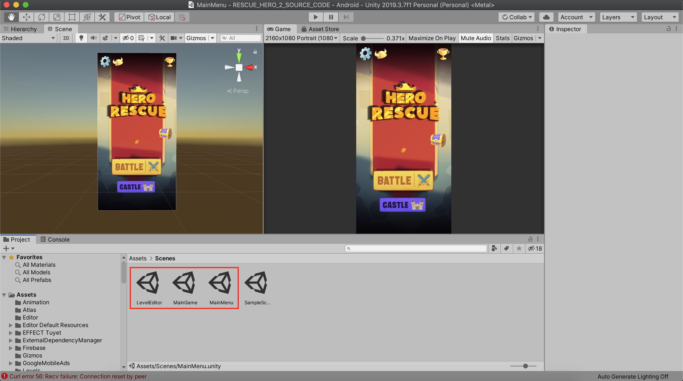

**8. Change images assets**

To change the image assets you need go to “**Resources**" - > “**Images**” and “**Spine**” folder in the project. In this folder, you can see all folders with game image assets. To change the style of any images or button, open the image file on the Photoshop or different image editor and start to redraw images. We recommend do not the change image size because after you save the image with a different size, the image may not display correctly in the game.

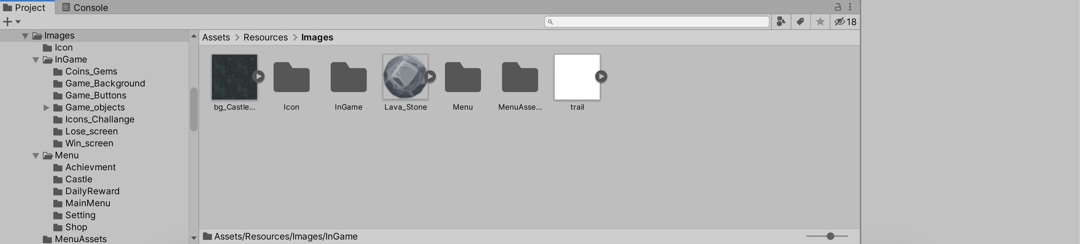

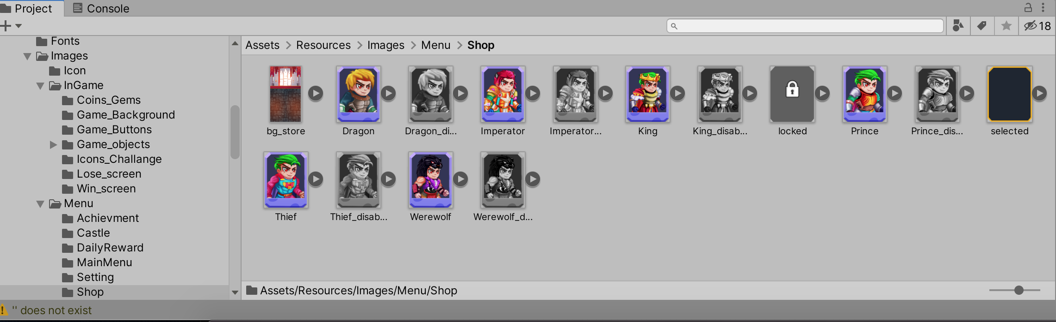

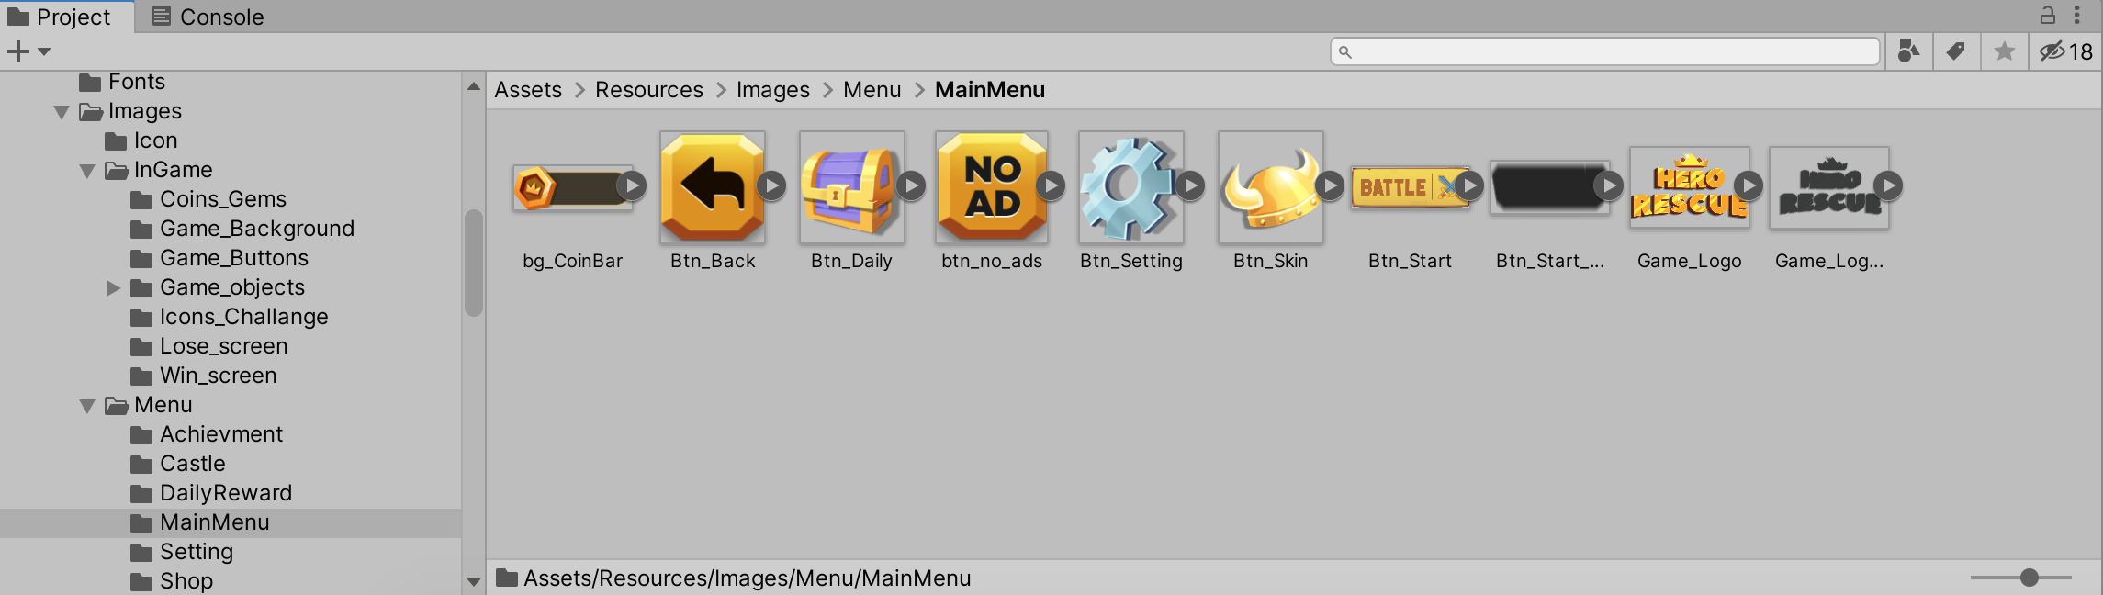

**9.Change game data**

To change game data you need go to “**Resources**” -> “**Data**”. You can change the “**Achievement**” and “**Hero**” data.

1. Change the “**Achievement**” data.

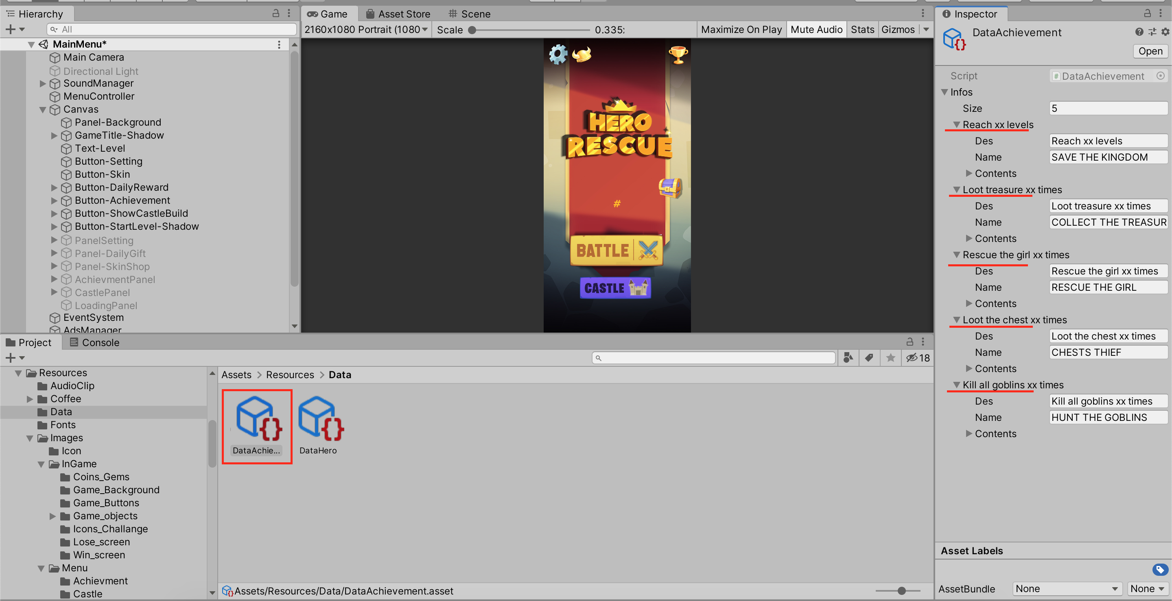

Open “**DataAchievement.asset**” and go to “**Inspector**” tab. You can change the name, descriptions, rewards value and number for all Achievements.

2. Change the “**Hero**” data.

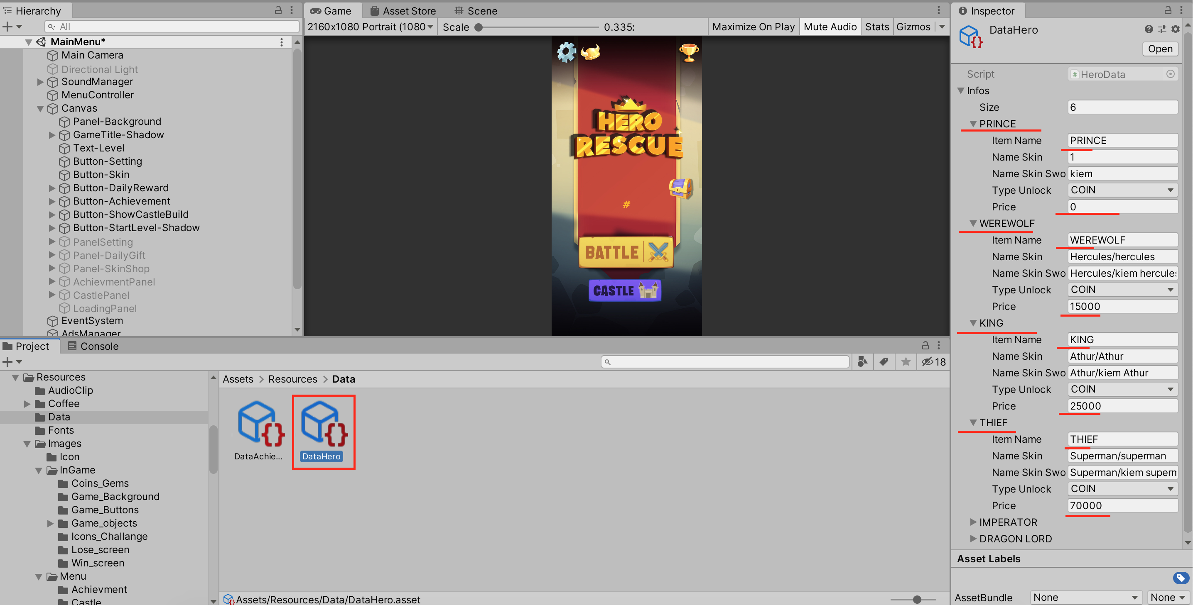

Open **“DataHero.asset”** and go to “**Inspector”** tab. You can change the names of heroes, skins names and heroes price..

**10. AdMob & In-App Purchase**

To add you “**AdMob**” ads and “**In-App**” purchase to the game, you need go to “**Scripts**” -> **”Utils”** and open **“Utils.cs”.**

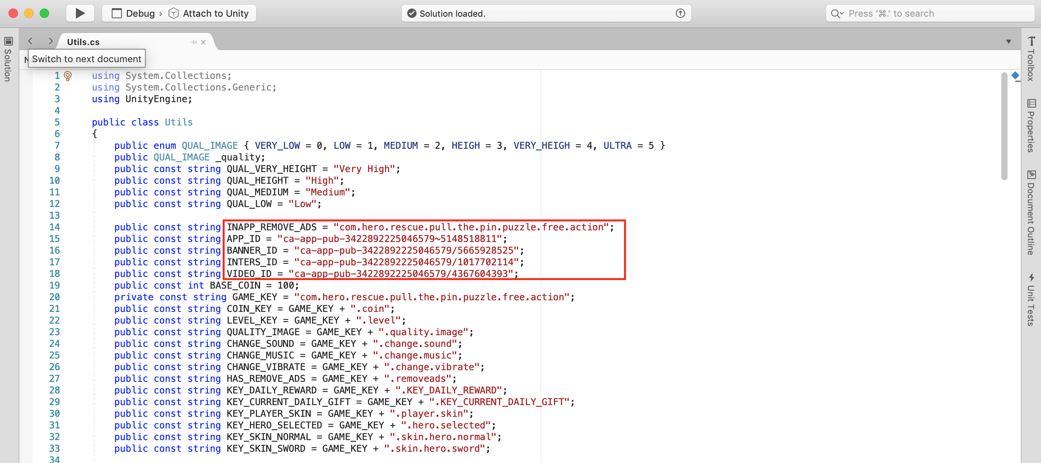

Set your AdMob IDs in following lines.

You need set your AdMob "**App ID**" to "**APP_ID**", "**Interstitial ID**" to “**INTERS_ID**”, "**Rewarded video ID**" to “**VIDEO_ID**”

**11. Change App name and Icon**

To change “**App name**” and “**Icon**” you need go to the menu “**File**” -> “**Build Settings**” -> “**Player Settings**”

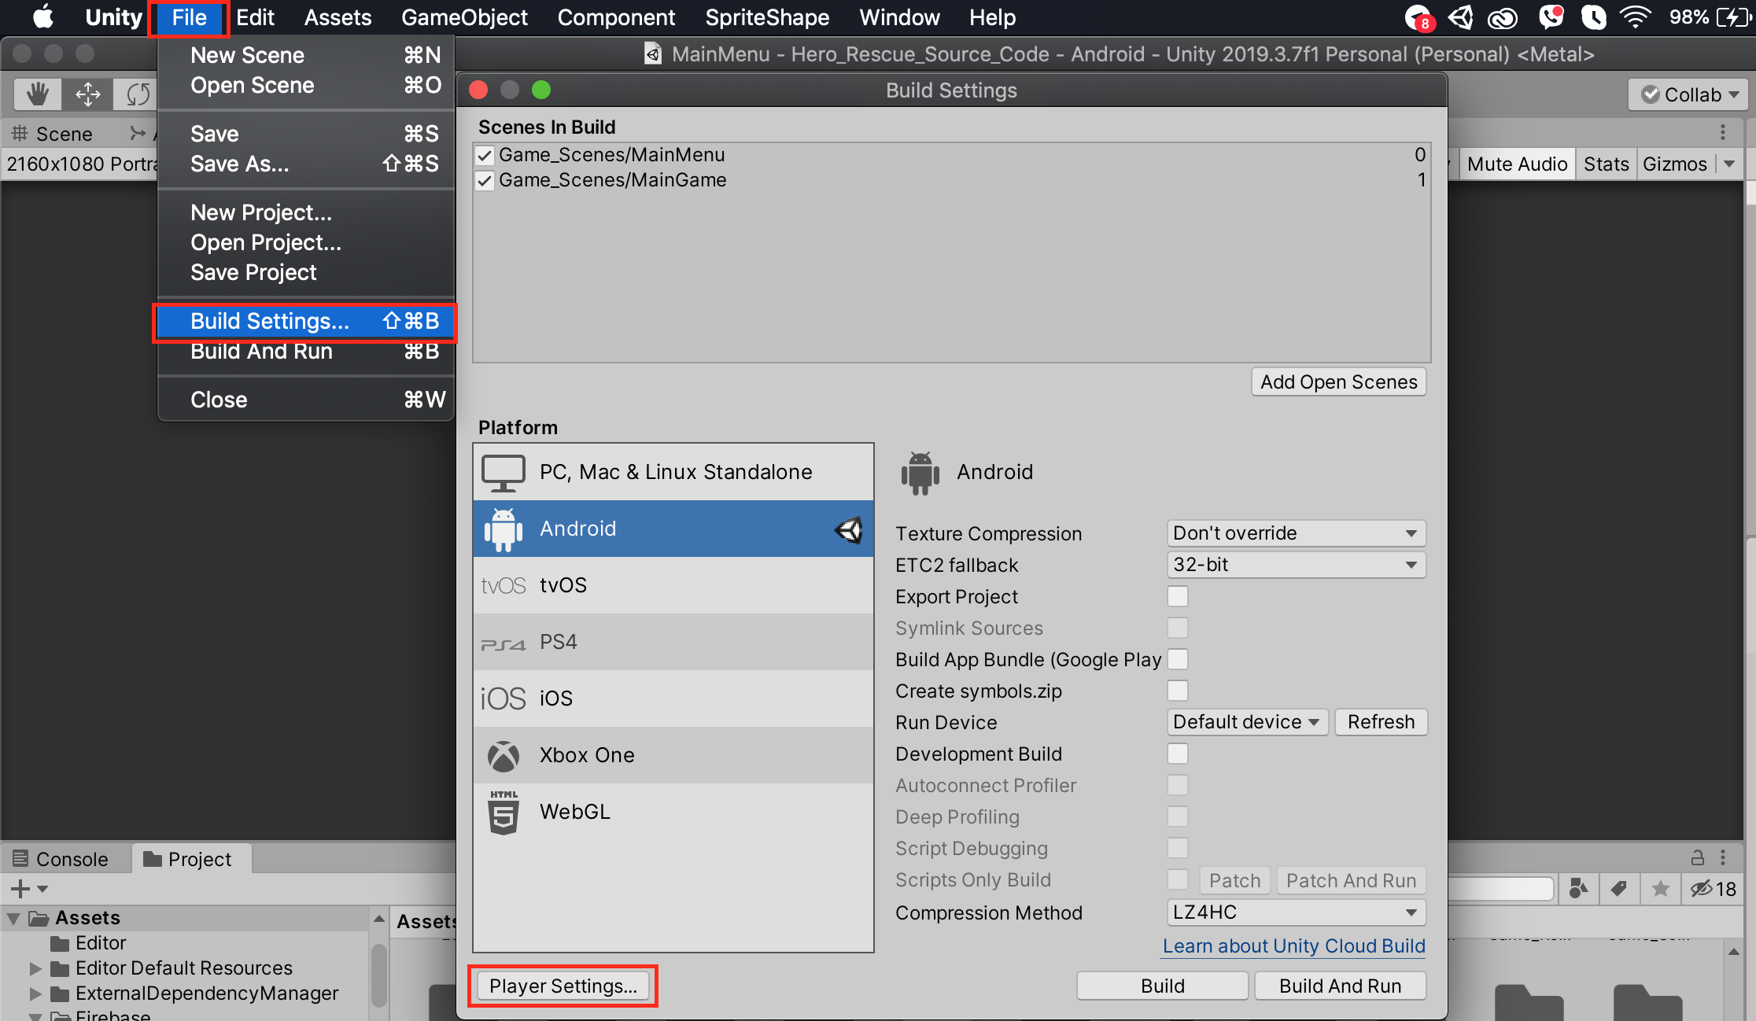

In “**Player Settings**” you can see the “**Product name**”, ”**Company name**” and "**Default Icon**" field. You can change the values of this fields and put your app name, icon, publisher name.

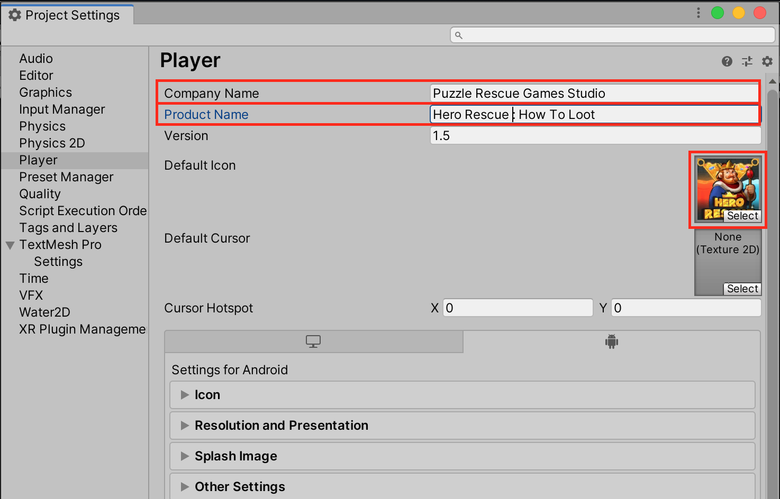

**12. Change package name**

In “**Player Settings** “ you need go to the "**Other Settings**" -> "**Identification**" tab and put package name of you game.

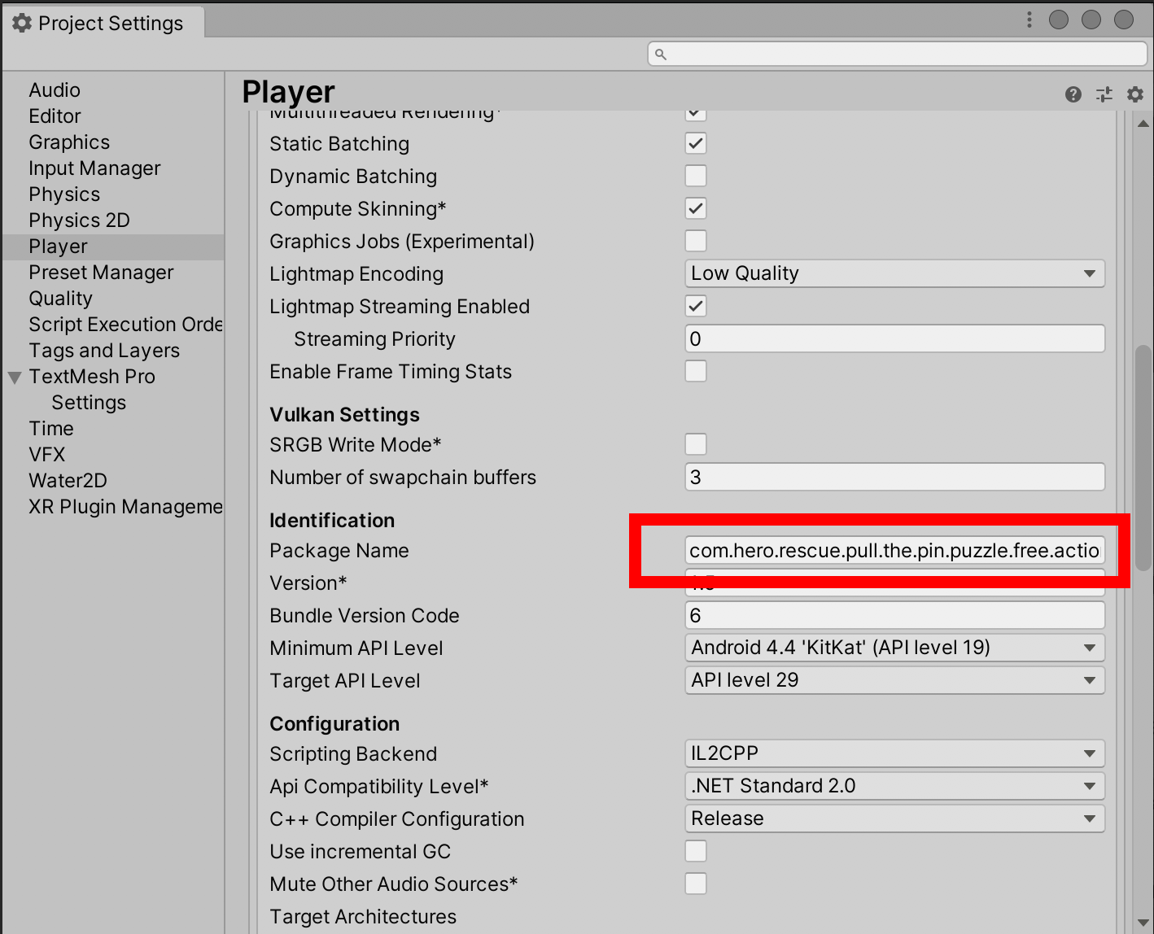

**11.Create a new “keystore” file**

In “**Player Settings** “ you need go to "**Publishing Settings**" and click to the "**Keystore Manager**" button.

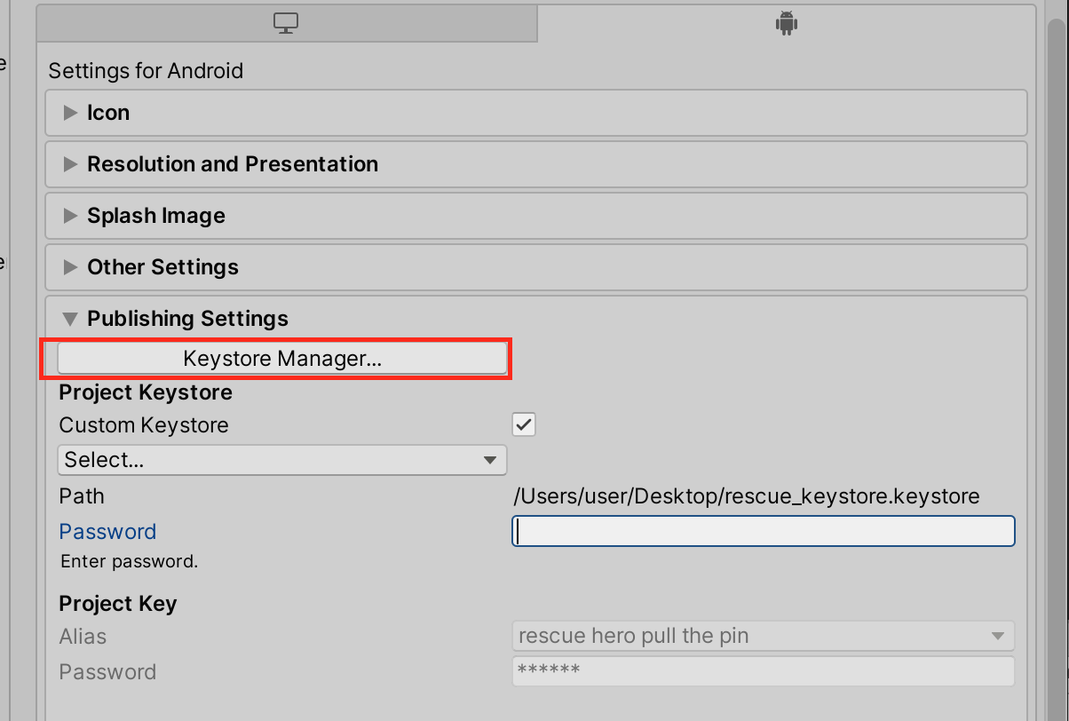

Next, you can see the “**Keystore Manager**” window and you need click the “**Keystore**” -> “**Create new**” and choose folder and click “**Save**” button.

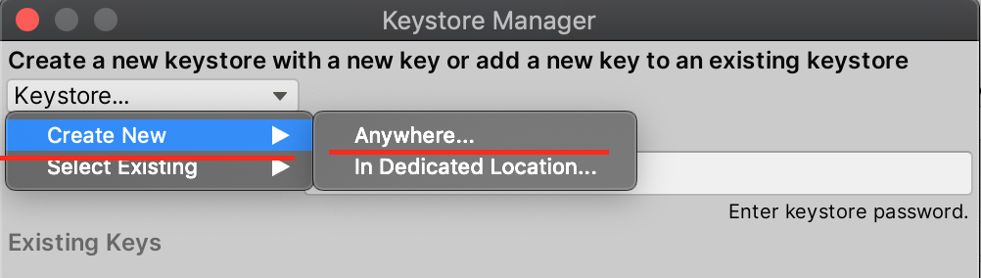

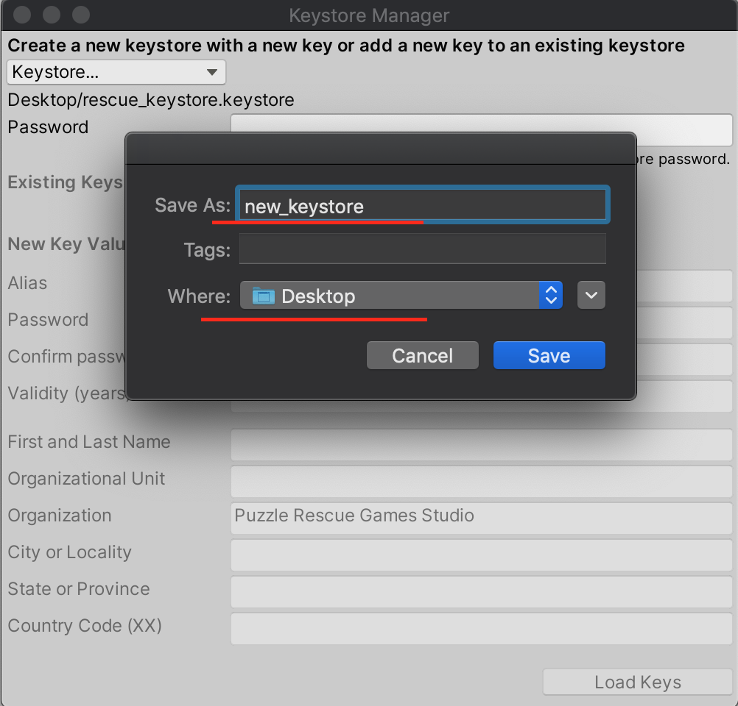

Next, you need to fill in all the fields on this tab and click “**Add Key**” button.

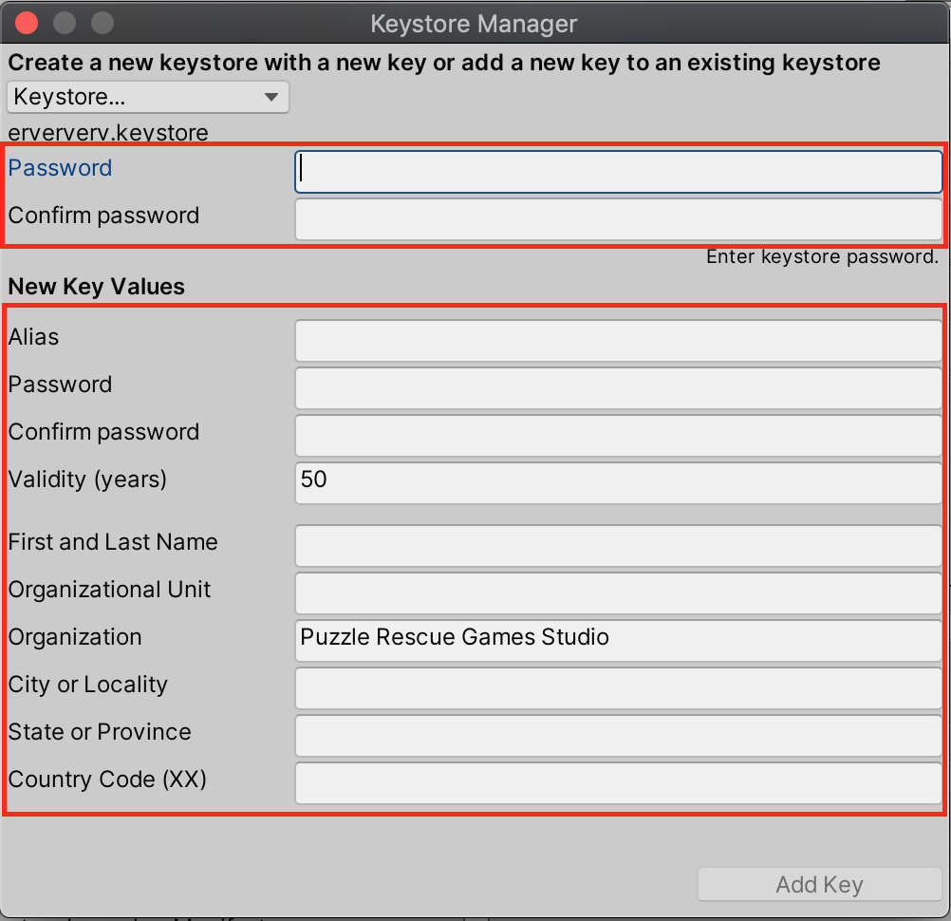

Done..

**12. Set up the Firebase**

To set up the **Firebase** you need open you browser and go to Firebase website (**http://firebase.google.com**)

First you need log in you Gmail account. On the Firebase website you need click the “**Add New Project**” button.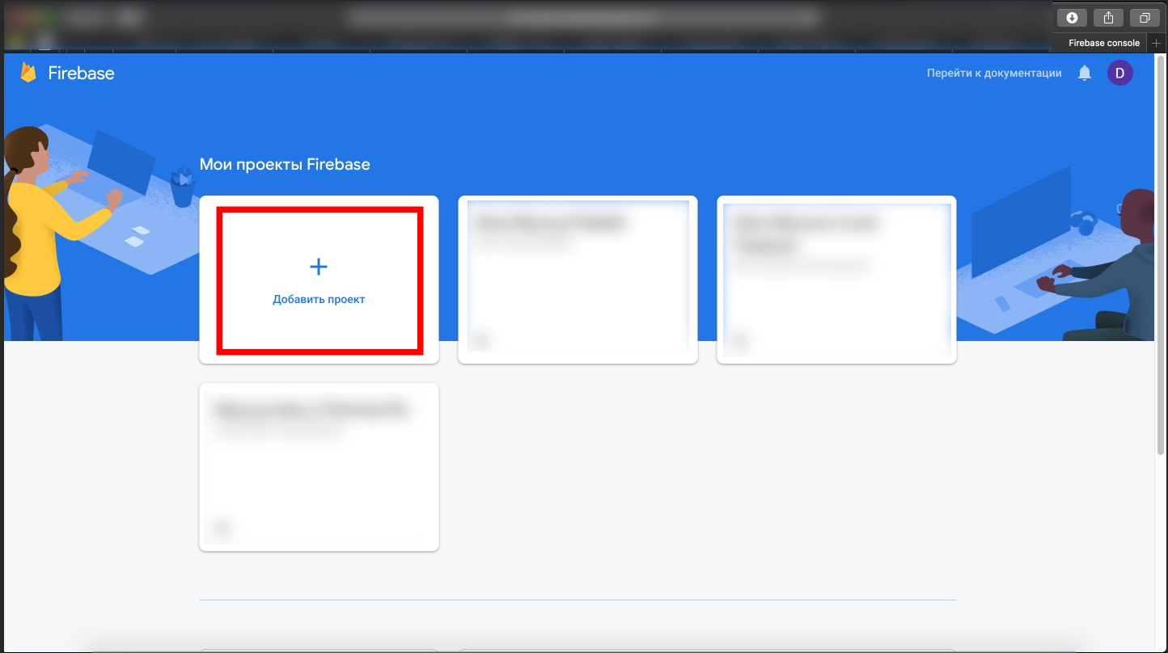

Next, you need put Project name.

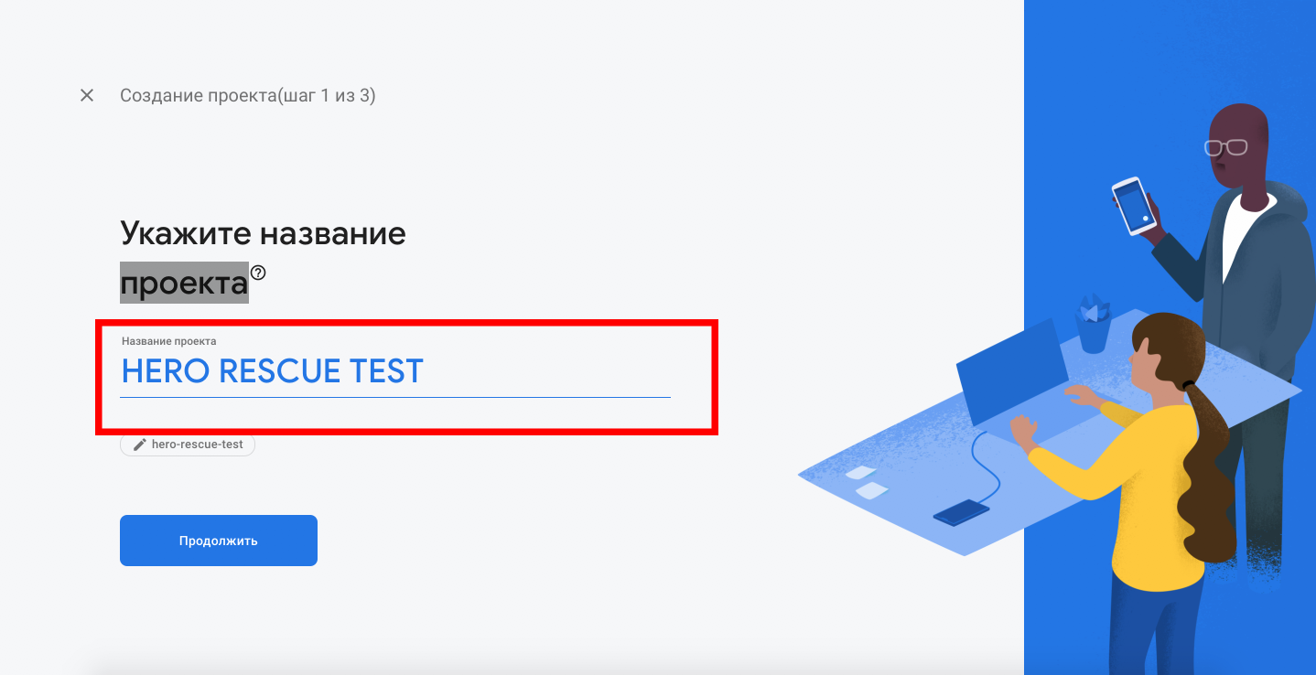

After you put the name and click the continue button you redirect to dashboard. On the **Dashboard** page you need go to “**Project settings”**.

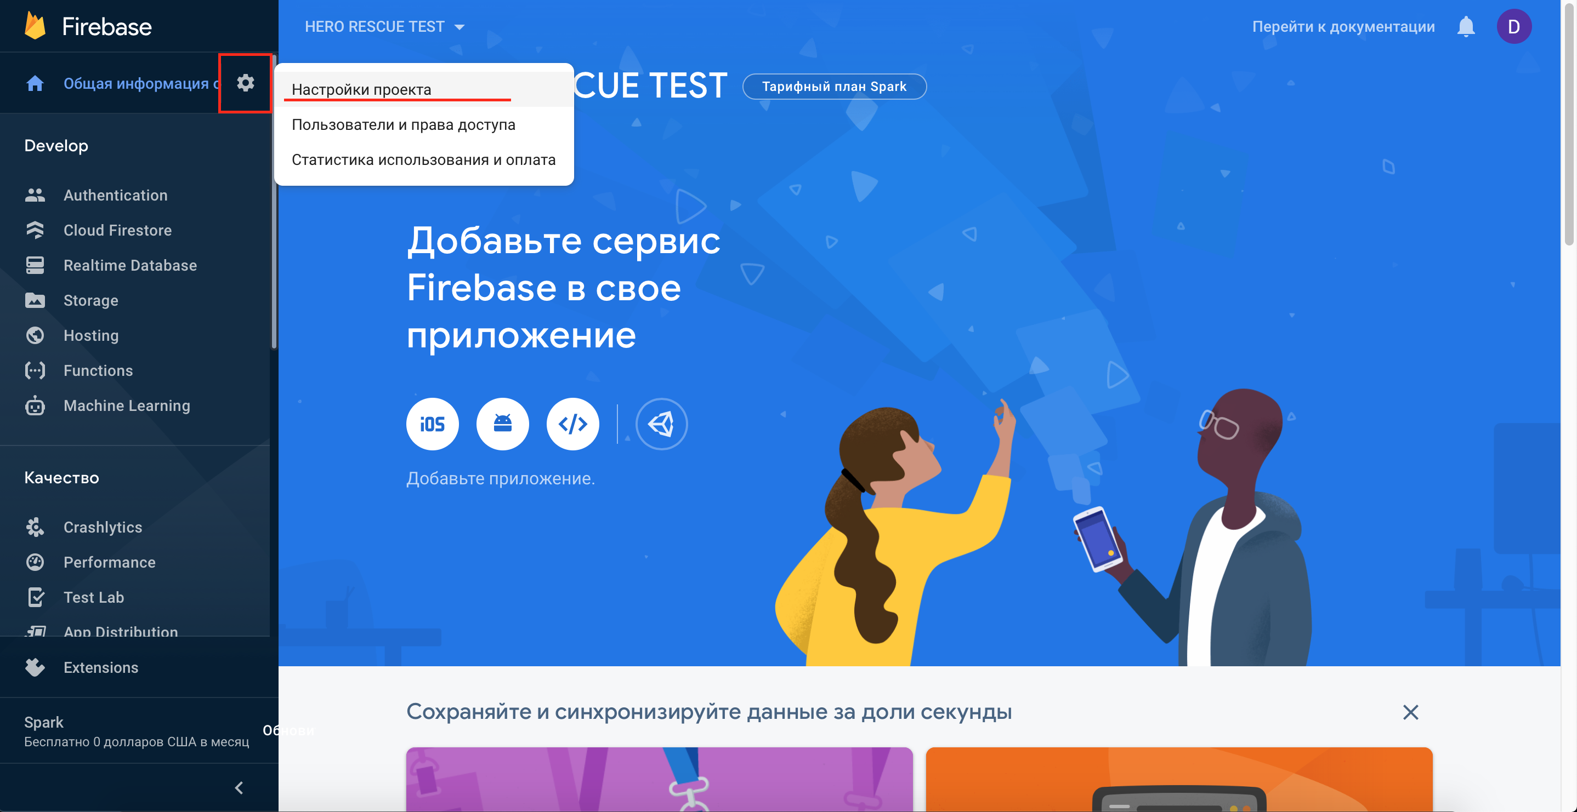

Next, go to “Your apps” sections and click to “**Unity**” icon.

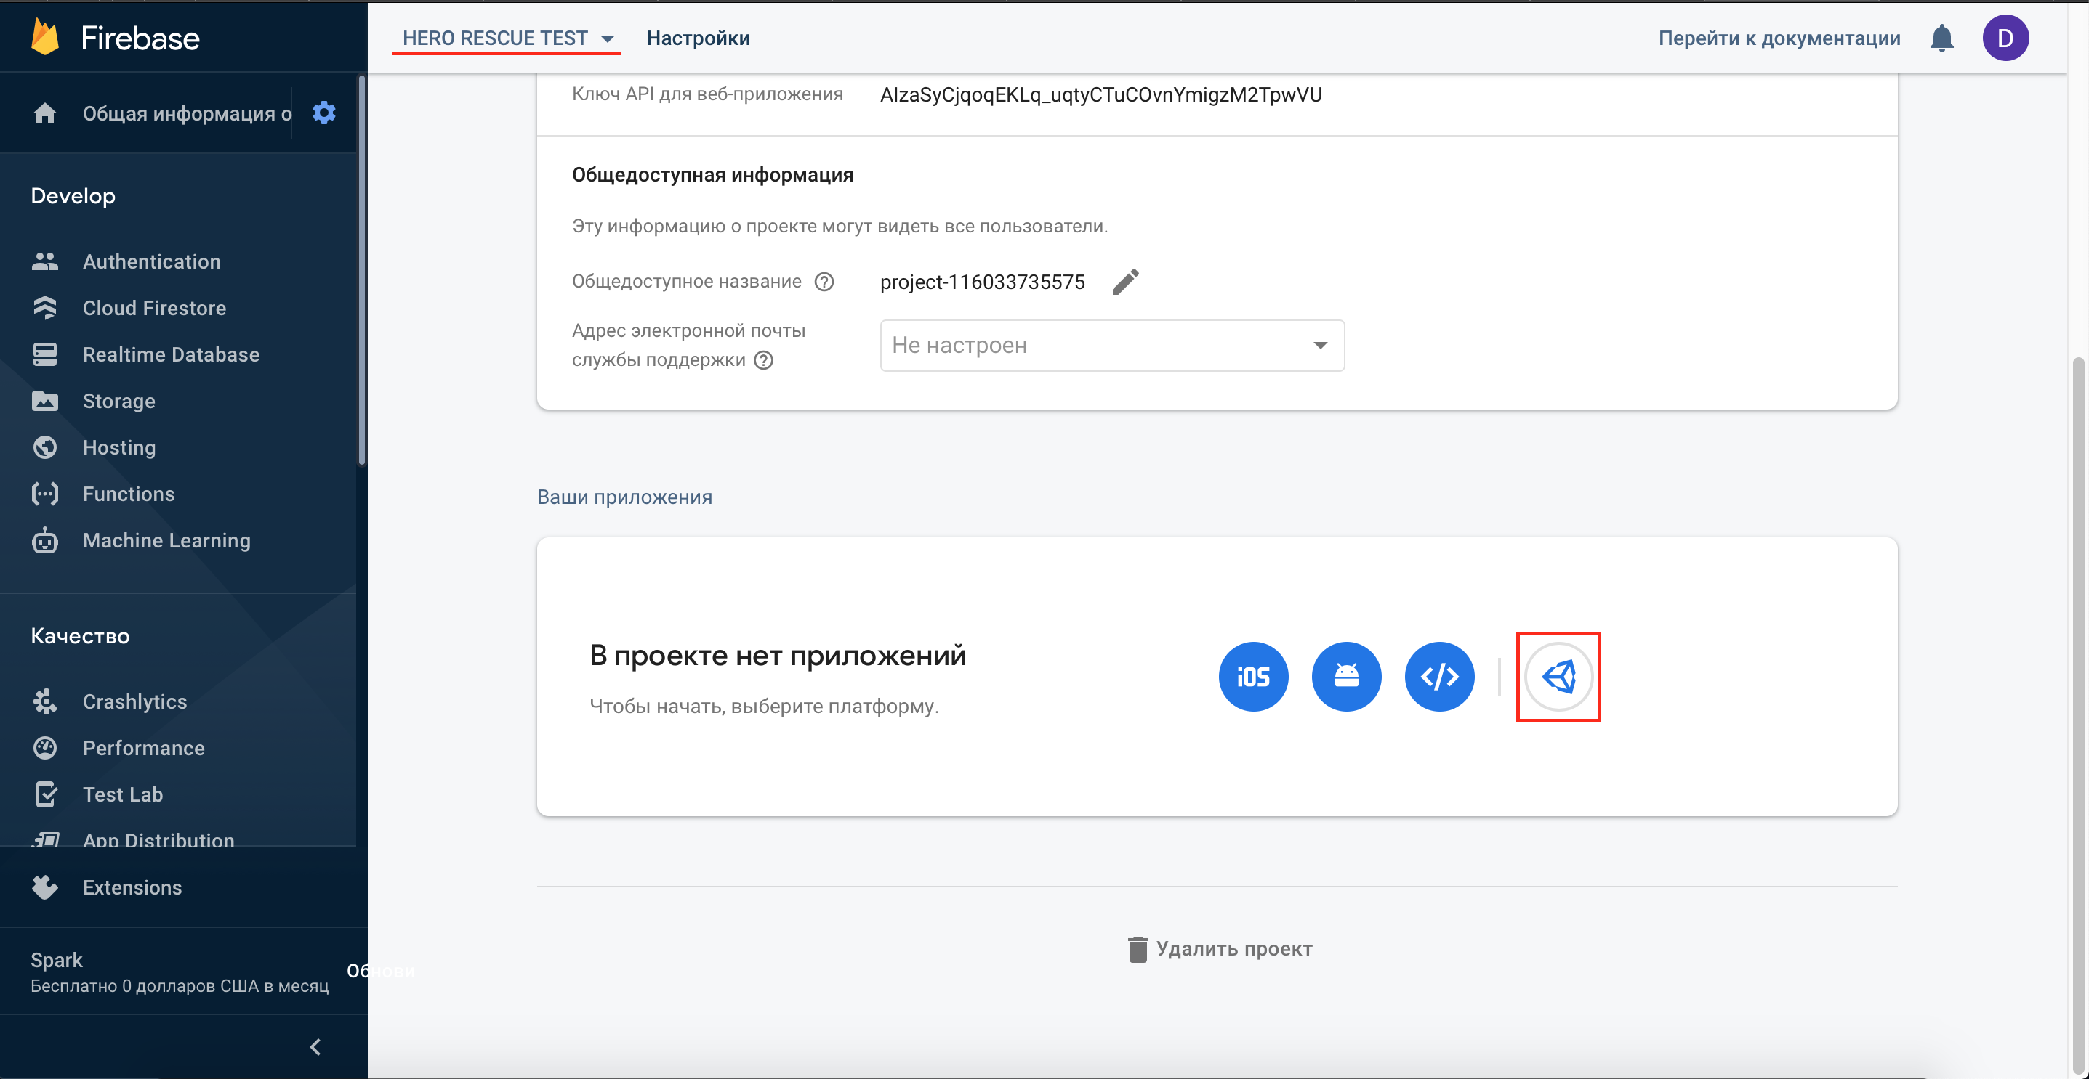

Next, you need choose **“Register as Android app**” and put you package name in this field and click the “**Register an app**”

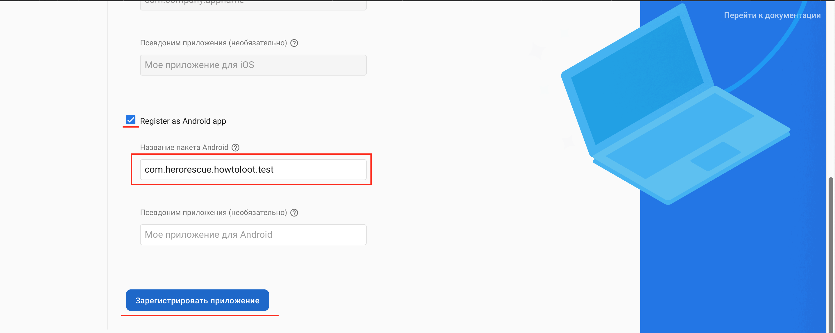

Next, you need click the “**Download google-services.json**” button.

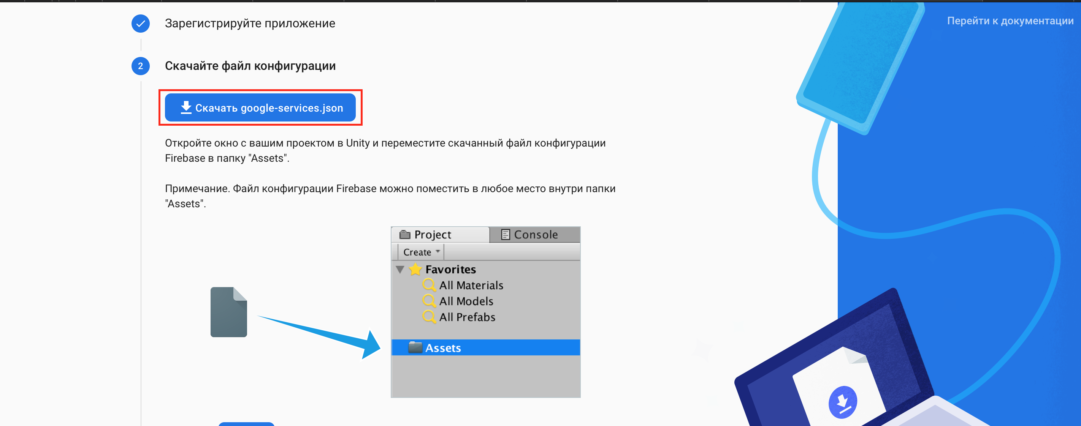

Upload the file and move it to the project folders.

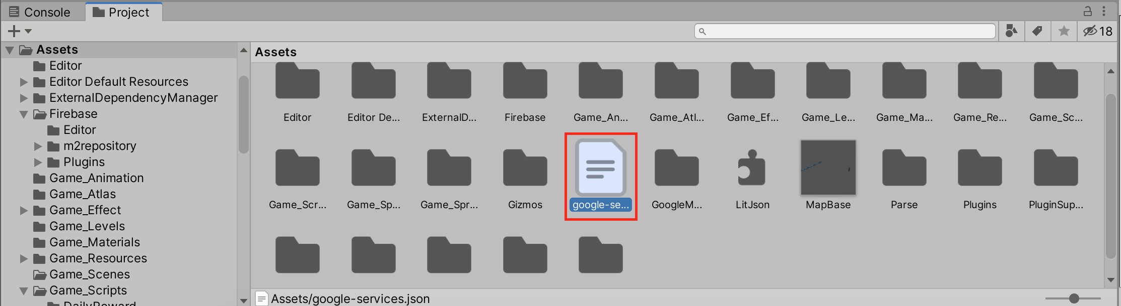

Done…

**13. Build an APK file**

To build the apk file, first, you need to add “**MainMenu.unity**” and “**MainGame.unity**” to “**Scenes in build**". Open the “**MainMenu.unity**” scene from the “**Game_Scenes**” folder and click the “**File**” -> **“Build Settings”** in tab menu**.** You need click the “**Add Open Scenes**” button to add the scene to “**Scenes In Build**”

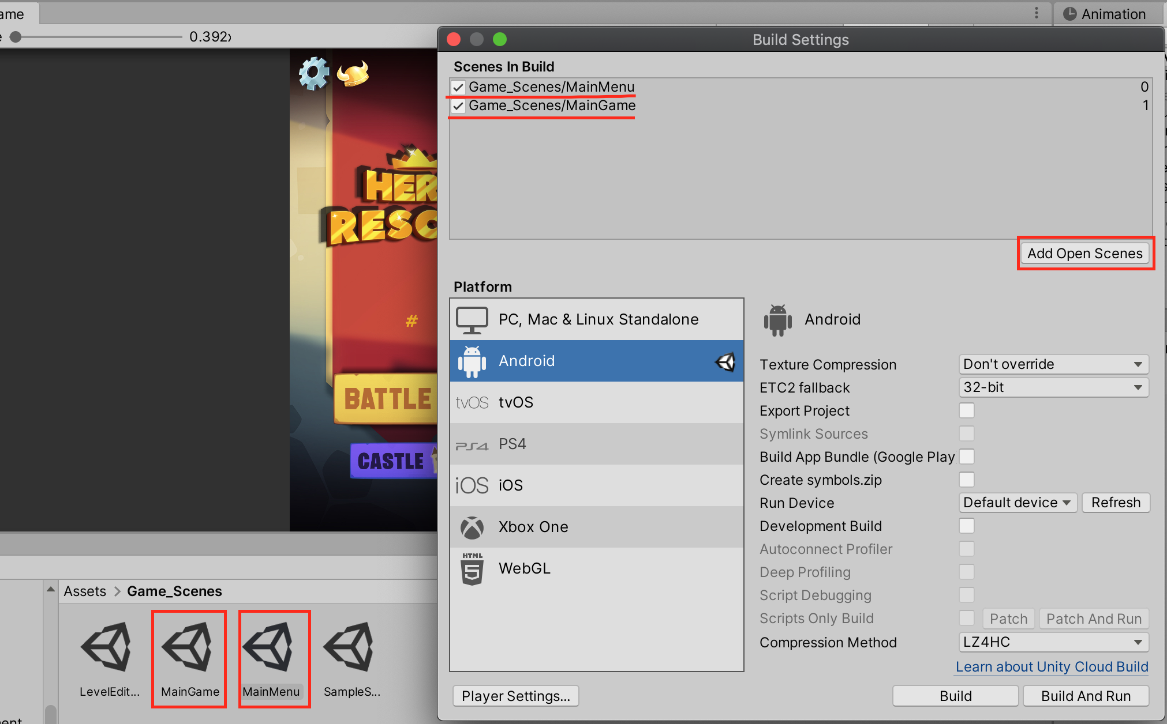

Repeat all the same actions with the scene "**MainGame**" to add it to the "Scenes In Build" section.

To make a ready APK file, you need to click the "**Build**" button, select the directory where you want to save the apk file, and click the “**Save**” button. Done…

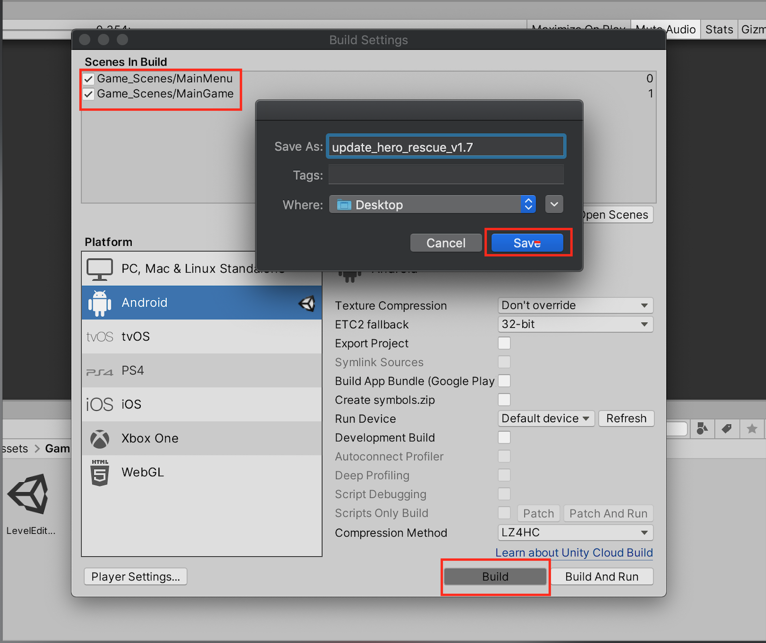

Done, you apk is ready to publish in Google Play.

**Contact us (24/7):**To get support please contact us.

Telegram: @AppsEmpire  
Gmail: azur.games.studio@gmail.com

**Thanks for purchase!!**